Project Number: 1

Project Name : Support Base

Project Complexity: Low

Project Overview:

Class project for ME10 (materials and manufacturing) to introduce us to solidworks, particularly the part aspect of things. The assignment required 3D modelling of a support base component in line with a provided engineering drawing and specification.

Tools used included the likes of the sketch tool, extrude/cut tools and chamfer/fillet tools. The project also built on ability to understand and use engineering drawings.

Project Images:

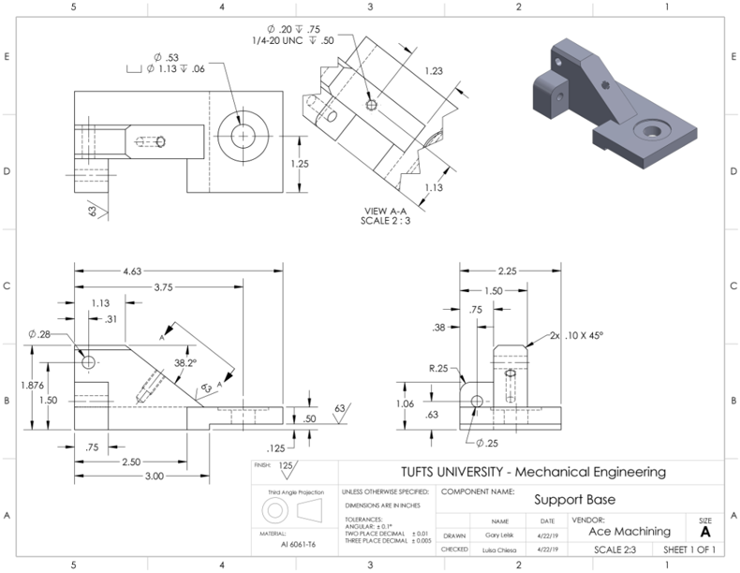

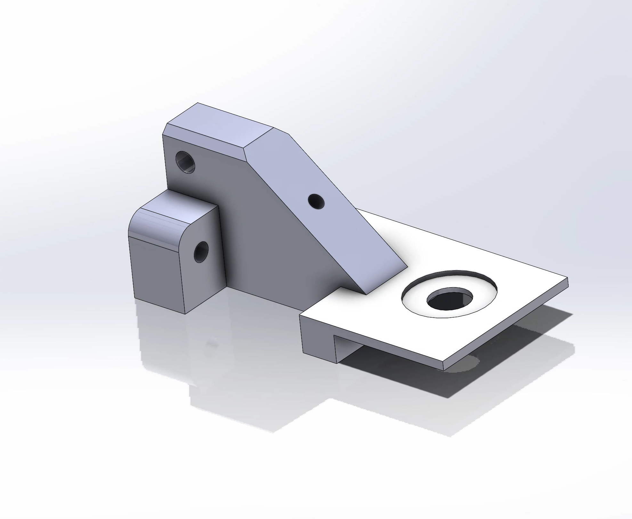 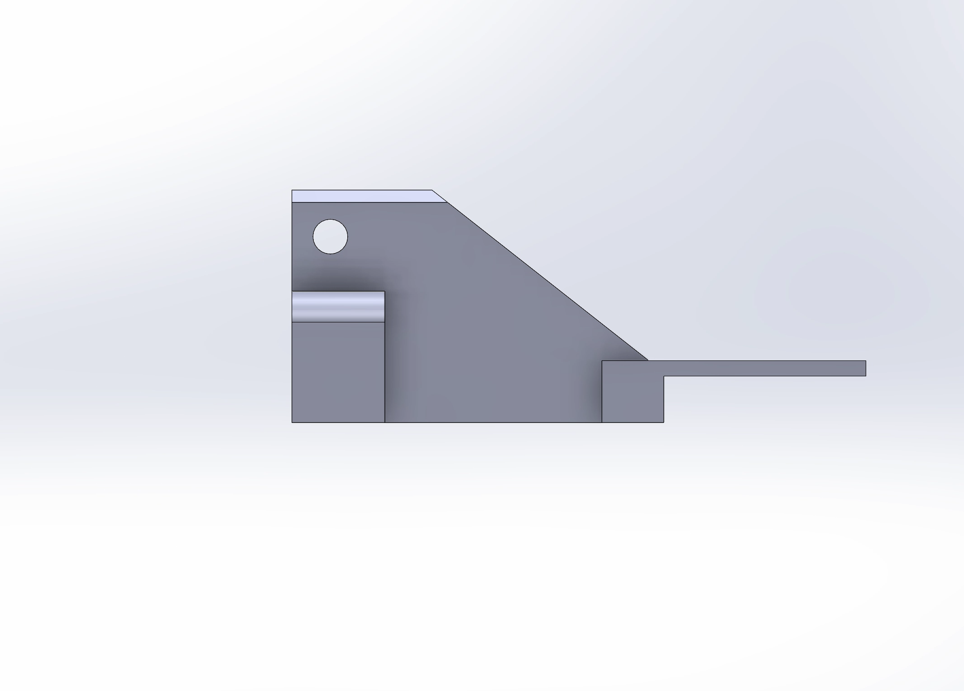

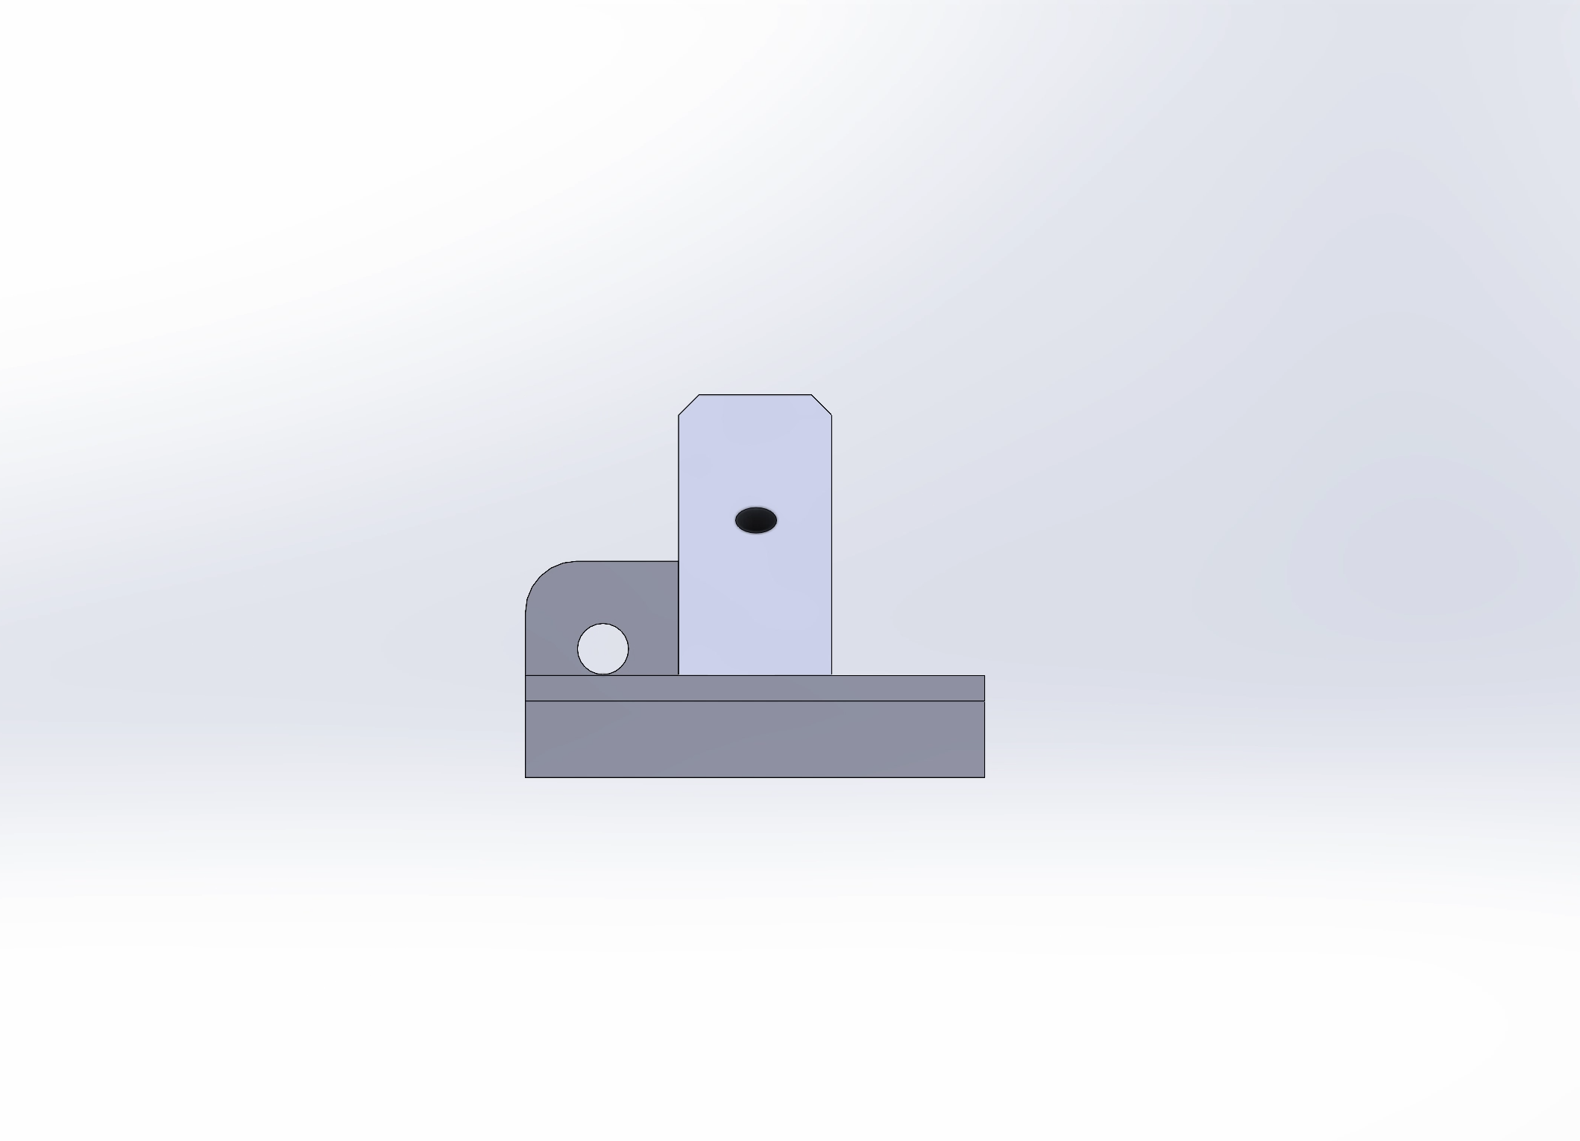

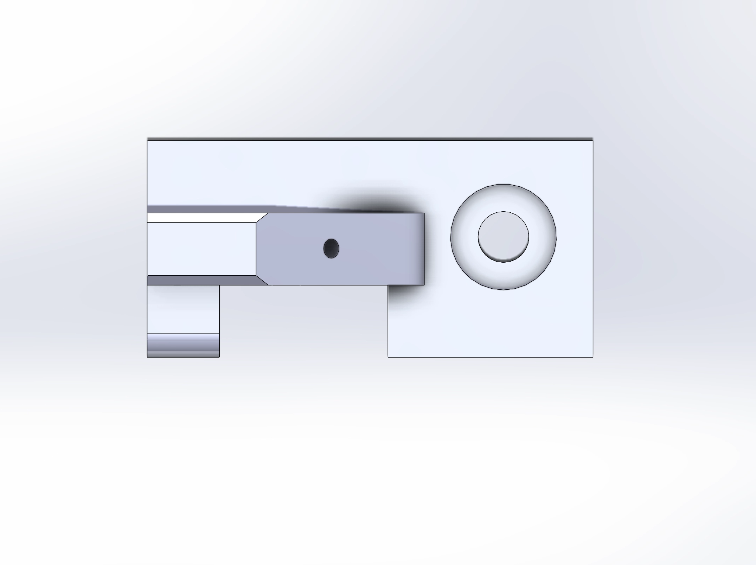

Project Outcome:

The project was a success, ability to effectively use basic features of solidworks was established. All requirements of the assignments original specification were met. In addition thanks to finish the project early given its relatively limited scope I was able to explore solidworks further, particularly the rendering and view side of things.